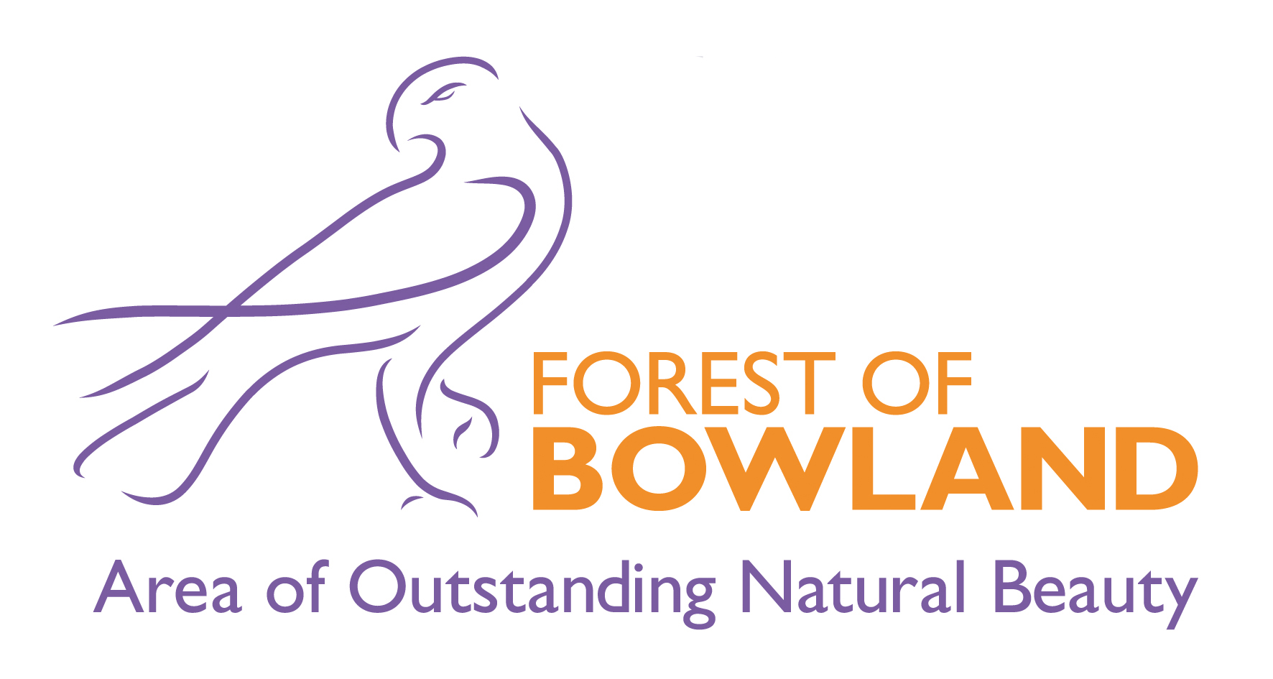

Forest of Bowland Area of Outstanding Natural Beauty Joint Advisory Committee

Thursday, 22nd April, 2021 at 2.00 pm in Zoom Virtual Meeting - Zoom

Agenda

<AI1>
- Welcome, Introductions and Apologies for Absence

<AI2>
- Disclosure of Pecuniary Interests
Members are asked to consider any Pecuniary Interests they may have to disclose to the meeting in relation to matters under consideration on the Agenda.

<AI3>
- Minutes of the Meeting held on 22 October 2022 |  |  | (Pages 1 - 14)
 | The Committee is asked to consider approving the minutes of the meetings held on 22 October 2020.

<AI4>
- Partner Updates |  |  | (Verbal Report)
 | (Open to all)

<AI5>
- Visitor Management During COVID19 |  |  | (Verbal Report)
 | (Presentation by Sarah Dornan, AONB and Pendle Hill Landscape Partnership Countryside Access Officer)

<AI6>
- AONB Partnership Budget | (Pages 15 - 18)

<AI7>
- AONB Unit Activity Report (Oct 2020 - April 2021) | (Pages 19 - 30)

<AI8>
- Pendle Hill Landscape Partnership

<AI9>
- Farming in Protected Landscapes | (Pages 31 - 32)

<AI10>
- NAAONB Art in the Landscape Strategy | (Pages 33 - 36)

<AI11>
- Urgent Business
An item of Urgent Business may only be considered under this heading where, by reason of special circumstances to be recorded in the minutes, the Chairman of the meeting is of the opinion that the item should be considered at the meeting as a matter of urgency. Wherever possible, the Chief Executive should be given advance warning of any Members' intention to raise a matter under this heading.

<AI12>
- Date of Next Meeting
The proposed dates and provisional locations of the Committee meetings (COVID-19 permitting) to be held in 2021 are:
21 October 2021 in Craven, venue tbc
21 April 2021 in Ribble Valley, venue tbc

Samantha Gorton
Democratic Services

Lancashire County Council
County Hall
Preston

<TITLED_COMMENT_LAYOUT_SECTION>

<COMMENT_LAYOUT_SECTION>

